Interactive Map with Folium
Estimated time needed: 40 minutes
The launch success rate may depend on many factors such as payload mass, orbit type, and so on. It may also depend on the location and proximities of a launch site, i.e., the initial position of rocket trajectories. Finding an optimal location for building a launch site certainly involves many factors and hopefully we could discover some of the factors by analyzing the existing launch site locations.
In the previous exploratory data analysis labs, you have visualized the SpaceX launch dataset using matplotlib and seaborn and discovered some preliminary correlations between the launch site and success rates. In this lab, you will be performing more interactive visual analytics using Folium.
Objectives
This lab contains the following tasks:
- TASK 1: Mark all launch sites on a map
- TASK 2: Mark the success/failed launches for each site on the map
- TASK 3: Calculate the distances between a launch site to its proximities
After completed the above tasks, you should be able to find some geographical patterns about launch sites.
Let's first import required Python packages for this lab:
import piplite
await piplite.install(['folium'])
await piplite.install(['pandas'])
then
import folium
import pandas as pd
Then
# Import folium MarkerCluster plugin
from folium.plugins import MarkerCluster
# Import folium MousePosition plugin
from folium.plugins import MousePosition
# Import folium DivIcon plugin
from folium.features import DivIcon
If you need to refresh your memory about folium, you may download and refer to this previous folium lab:
Generating Maps with Python
Task 1: Mark all launch sites on a map
First, let's try to add each site's location on a map using site's latitude and longitude coordinates
The following dataset with the name spacex_launch_geo.csv is an augmented dataset with latitude and longitude added for each site.
# Download and read the `spacex_launch_geo.csv`
from js import fetch
import io

URL = 'https://cf-courses-data.s3.us.cloud-object-storage.appdomain.cloud/IBM-DS0321EN-SkillsNetwork/datasets/spacex_launch_geo.csv'
resp = await fetch(URL)
spacex_csv_file = io.BytesIO((await resp.arrayBuffer()).to_py())
spacex_df=pd.read_csv(spacex_csv_file)
Now, you can take a look at what are the coordinates for each site.
# Select relevant sub-columns: `Launch Site`, `Lat(Latitude)`, `Long(Longitude)`, `class`
spacex_df = spacex_df[['Launch Site', 'Lat', 'Long', 'class']]
launch_sites_df = spacex_df.groupby(['Launch Site'], as_index=False).first()
launch_sites_df = launch_sites_df[['Launch Site', 'Lat', 'Long']]
launch_sites_df
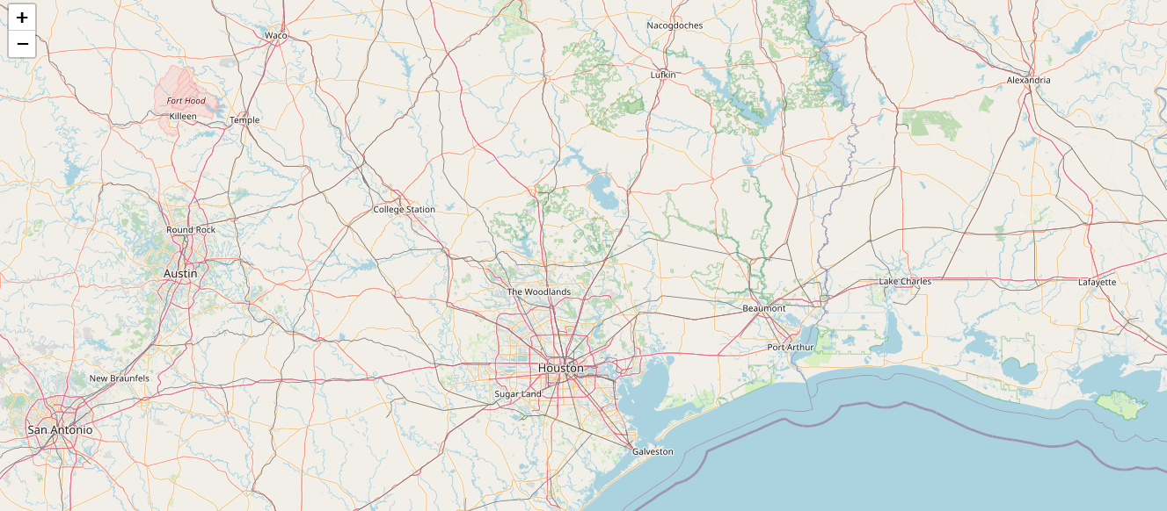
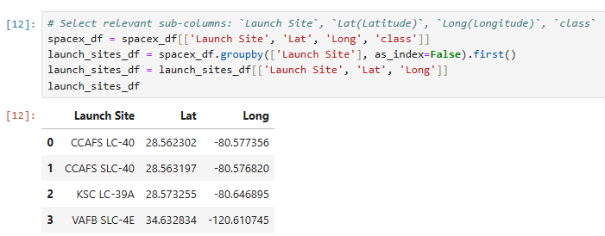
Above coordinates are just plain numbers that can not give you any intuitive insights about where are those launch sites. If you are very good at geography, you can interpret those numbers directly in your mind. If not, that's fine too. Let's visualize those locations by pinning them on a map.
We first need to create a folium Map object, with an initial center location to be NASA Johnson Space Center at Houston, Texas.
# Start location is NASA Johnson Space Center
nasa_coordinate = [29.559684888503615, -95.0830971930759]
site_map = folium.Map(location=nasa_coordinate, zoom_start=10)
We could use folium. Circle to add a highlighted circle area with a text label on a specific coordinate. For example,
# Create a blue circle at NASA Johnson Space Center's coordinate with a popup label showing its name
circle = folium.Circle(nasa_coordinate, radius=1000, color='#d35400', fill=True).add_child(folium.Popup('NASA Johnson Space Center'))
# Create a blue circle at NASA Johnson Space Center's coordinate with a icon showing its name
marker = folium.map.Marker(
nasa_coordinate,
# Create an icon as a text label
icon=DivIcon(
icon_size=(20,20),
icon_anchor=(0,0),
html='<div style="font-size: 12; color:#d35400;"><b>%s</b></div>' % 'NASA JSC',
)
)
site_map.add_child(circle)
site_map.add_child(marker)
(# I did not have the option in my lab to do the File > Trust – which is required to see the map)
and you should find a small yellow circle near the city of Houston and you can zoom-in to see a larger circle.
Now, let's add a circle for each launch site in data frame launch_sites
TODO: Create and add folium.Circle and folium.Marker for each launch site on the site map
An example of folium.Circle:
folium.Circle(coordinate, radius=1000, color='#000000', fill=True).add_child(folium.Popup(...))
An example of folium.Marker:
folium.map.Marker(coordinate, icon=DivIcon(icon_size=(20,20),icon_anchor=(0,0), html='<div style="font-size: 12; color:#d35400;"><b>%s</b></div>' % 'label', ))
The generated map with marked launch sites should look similar to the following:
# Define A coordinates
a_coordinate = [28.562302, -80.577356]

# Initial the map
a_site_map = folium.Map(location=a_coordinate, zoom_start=5)

# For each launch site, add a Circle object based on its coordinate (Lat, Long) values. In addition, add Launch site name as a popup label
folium.Circle(a_coordinate, radius=1000, color='#000000', fill=True).add_child(folium.Popup('Nasa Cape Canaveral'))
folium.map.Marker(a_coordinate, icon=DivIcon(icon_size=(20,20), icon_anchor=(0,0), html='<div style="font-size: 12; color:#d35400;"><b>%s</b></div>' % 'Nasa Cape Canaveral',))
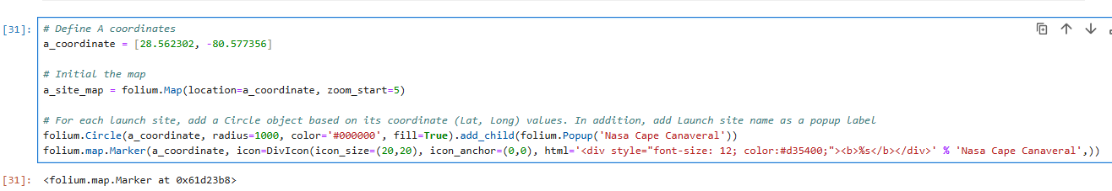
<folium.map.Marker at 0x61d23b8>
Then
# Define B coordinates
b_coordinate = [28.563197, -80.576820]

# Initial the map
b_site_map = folium.Map(location=b_coordinate, zoom_start=5)

# For each launch site, add a Circle object based on its coordinate (Lat, Long) values. In addition, add Launch site name as a popup label
folium.Circle(b_coordinate, radius=1000, color='#000000', fill=True).add_child(folium.Popup('Nasa Cape Canaveral Complex 40'))
folium.map.Marker(b_coordinate, icon=DivIcon(icon_size=(20,20), icon_anchor=(0,0), html='<div style="font-size: 12; color:#d35400;"><b>%s</b></div>' % 'Nasa Cape Canaveral Complex 40',))
Result: <folium.map.Marker at 0x5d419a8>
Then
# Define C coordinates
c_coordinate = [28.573255, -80.646895]
# Initial the map
c_site_map = folium.Map(location=c_coordinate, zoom_start=5)

# For each launch site, add a Circle object based on its coordinate (Lat, Long) values. In addition, add Launch site name as a popup label
folium.Circle(c_coordinate, radius=1000, color='#000000', fill=True).add_child(folium.Popup('Nasa Kennedy Space Center'))
folium.map.Marker(c_coordinate, icon=DivIcon(icon_size=(20,20), icon_anchor=(0,0), html='<div style="font-size: 12; color:#d35400;"><b>%s</b></div>' % 'Nasa Kennedy Space Center',))
Result: <folium.map.Marker at 0x61ea700>
Then
Define D coordinates
d_coordinate = [34.632834, -120.610745]

# Initial the map
d_site_map = folium.Map(location=d_coordinate, zoom_start=5)

# For each launch site, add a Circle object based on its coordinate (Lat, Long) values. In addition, add Launch site name as a popup label
folium.Circle(d_coordinate, radius=1000, color='#000000', fill=True).add_child(folium.Popup('Nasa Vandenberg Space Launch Complex'))
folium.map.Marker(d_coordinate, icon=DivIcon(icon_size=(20,20), icon_anchor=(0,0), html='<div style="font-size: 12; color:#d35400;"><b>%s</b></div>' % 'Nasa Vandenberg Space Launch Complex',))
Result: <folium.map.Marker at 0x5d447f8>
The generated map with marked launch sites should look similar to the following:
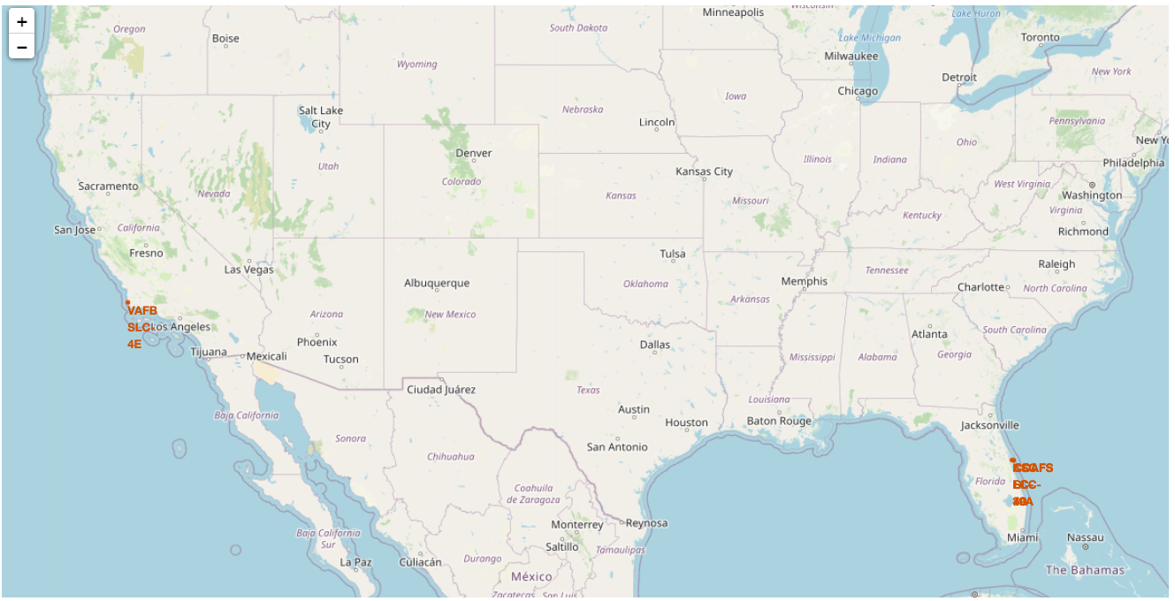
Now, you can explore the map by zoom-in/out the marked areas , and try to answer the following questions:
- Are all launch sites in proximity to the Equator line?
- Are all launch sites in very close proximity to the coast?
Also please try to explain your findings.
# My map won't display but I believe I set it up correctly. They are all near the coast.\
# I wouldn't really say they are next to the equator since that is in South America region,\
# however I would say they are all in the lower states probably closes in the US.
# in looking at the table above Launch Site KSC LC-39A - Kennedy Space Center has the most successful at 10
# and Cape Canaveral is next - but they also have the most failures at 19.
# Task 2: Mark the success/failed launches for each site on the map
# Step 1
site_summary = pd.DataFrame({
'Launch Site': ['CCAFS LC-40', 'CCAFS SLC-40', 'KSC LC-39A', 'VAFB SLC-4E'],
'class': [0, 1, 0, 1],
'count': [5, 10, 2, 3]
})

# Step 2 Bring in the coords from earlier
site_coords = {
'CCAFS LC-40': a_coordinate,
'CCAFS SLC-40': b_coordinate,
'KSC LC-39A': c_coordinate,
'VAFB SLC-4E': d_coordinate
}

# Create base map
m = folium.Map(location=[28.5, -80.6], zoom_start=5)

# Add markers
for _, row in site_summary.iterrows():
site = row['Launch Site']
outcome = row['class']
count = row['count']
coords = site_coords.get(site)

if coords:
color = 'green' if outcome == 1 else 'red'
popup_text = f"{site}<br>{'Success' if outcome == 1 else 'Failure'}: {count} launches"

folium.Marker(
location=coords,
popup=popup_text,
icon=folium.Icon(color=color, icon='rocket', prefix='fa')
).add_to(m)

# Display map
M
Next, let's try to enhance the map by adding the launch outcomes for each site, and see which sites have high success rates. Recall that data frame spacex_df has detailed launch records, and the class column indicates if this launch was successful or not
spacex_df.tail(10)
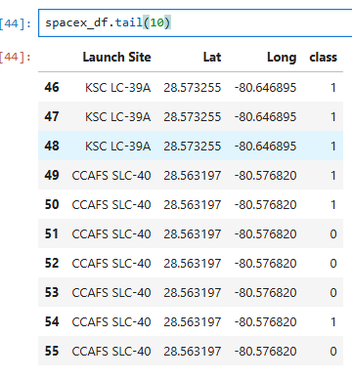
Next, let's create markers for all launch records. If a launch was successful (class=1), then we use a green marker and if a launch was failed, we use a red marker (class=0)
Note that a launch only happens in one of the four launch sites, which means many launch records will have the exact same coordinate. Marker clusters can be a good way to simplify a map containing many markers having the same coordinate.
Let's first create a MarkerCluster object
marker_cluster = MarkerCluster()
TODO: Create a new column in spacex_df dataframe called marker_color to store the marker colors based on the class value
# Apply a function to check the value of `class` column
# Above step 2 I already checked the counts in order to logically think through how to call it

# If class=1, marker_color value will be green
# I already did this in step 2 - I guess I did more than I was supposed to prior

# If class=0, marker_color value will be red
# I already did this in step 2 - I thought I was supposed to do that earlier
TODO: For each launch result in spacex_df data frame, add a folium.Marker to marker_cluster
# Add marker_cluster to current site_map
site_map.add_child(marker_cluster)

# for each row in spacex_df data frame
# create a Marker object with its coordinate
# and customize the Marker's icon property to indicate if this launch was successed or failed,
# e.g., icon=folium.Icon(color='white', icon_color=row['marker_color']

for index, record in spacex_df.iterrows():
# TODO: Create and add a Marker cluster to the site map
lat = record['Lat']
lon = record['Long']

# Determine marker color based on class
outcome = record['class']
color = 'green' if outcome == 1 else 'red'

# marker = folium.Marker(...)
marker = folium.Marker(
location=[lat, lon],
popup=popup_text,
icon=folium.Icon(color=color, icon='rocket', prefix='fa')
)

marker_cluster.add_child(marker)

# Display the map
site_map
Your updated map may look like the following screenshots:
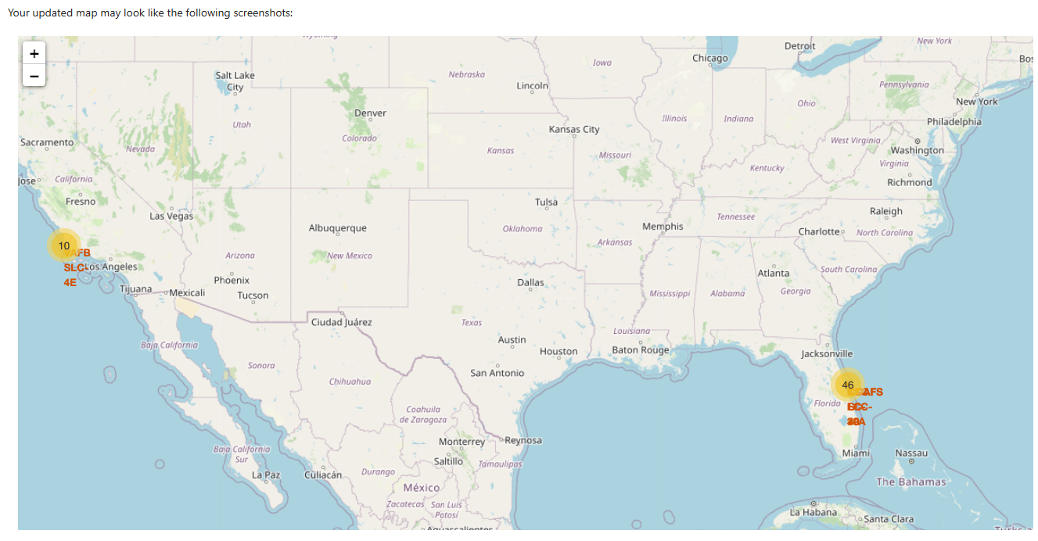
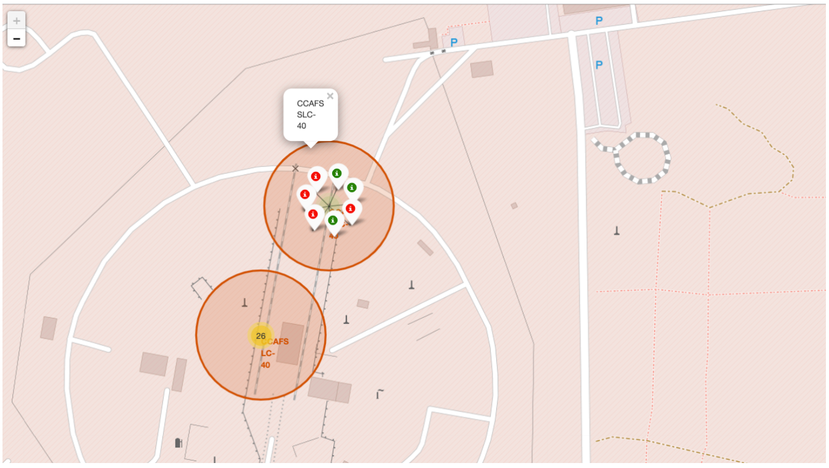
From the color-labeled markers in marker clusters, you should be able to easily identify which launch sites have relatively high success rates.
TASK 3: Calculate the distances between a launch site to its proximities
Next, we need to explore and analyze the proximities of launch sites.
Let's first add a MousePosition on the map to get coordinate for a mouse over a point on the map. As such, while you are exploring the map, you can easily find the coordinates of any points of interests (such as railway)
# Add Mouse Position to get the coordinate (Lat, Long) for a mouse over on the map
formatter = "function(num) {return L.Util.formatNum(num, 5);};"
mouse_position = MousePosition(
position='topright',
separator=' Long: ',
empty_string='NaN',
lng_first=False,
num_digits=20,
prefix='Lat:',
lat_formatter=formatter,
lng_formatter=formatter,
)

site_map.add_child(mouse_position)
site_map
Now zoom in to a launch site and explore its proximity to see if you can easily find any railway, highway, coastline, etc. Move your mouse to these points and mark down their coordinates (shown on the top-left) in order to the distance to the launch site.
from math import sin, cos, sqrt, atan2, radians

def calculate_distance(lat1, lon1, lat2, lon2):
# approximate radius of earth in km
R = 6373.0

lat1 = radians(lat1)
lon1 = radians(lon1)
lat2 = radians(lat2)
lon2 = radians(lon2)

dlon = lon2 - lon1
dlat = lat2 - lat1

a = sin(dlat / 2)**2 + cos(lat1) * cos(lat2) * sin(dlon / 2)**2
c = 2 * atan2(sqrt(a), sqrt(1 - a))

distance = R * c
return distance
TODO: Mark down a point on the closest coastline using MousePosition and calculate the distance between the coastline point and the launch site.
# find coordinate of the closet coastline (CCAFS LC-40)
# e.g.,: Lat: 28.56367 Lon: -80.57163
launch_site_lat = 28.562302
launch_site_lon = -80.577356

# manually selected lat/long
coastline_lat = 28.56367
coastline_lon = -80.57163

# distance_coastline = calculate_distance(launch_site_lat, launch_site_lon, coastline_lat, coastline_lon)
# calculate distance
distance = calculate_distance(launch_site_lat, launch_site_lon, coastline_lat, coastline_lon)
Then
# Create and add a folium.Marker on your selected closest coastline point on the map
folium.Marker(
location=[coastline_lat, coastline_lon],
popup="Closest Coastline",
icon=folium.Icon(color='blue')
).add_to(site_map)

# Display the distance between coastline point and launch site using the icon property

# for example
# distance_marker = folium.Marker(
# coordinate,
# icon=DivIcon(
# icon_size=(20,20),
# icon_anchor=(0,0),
# html='<div style="font-size: 12; color:#d35400;"><b>%s</b></div>' % "{:10.2f} KM".format(distance),
# )
# )
distance_marker = folium.Marker(
location=[coastline_lat, coastline_lon],
icon=DivIcon(
icon_size=(150, 36),
icon_anchor=(0, 0),
html='<div style="font-size: 12px; color:#d35400;"><b>%s</b></div>' % "{:10.2f} KM".format(distance),
)
)
TODO: Draw a PolyLine between a launch site to the selected coastline point
# Create a `folium.PolyLine` object using the coastline coordinates and launch site coordinate
# lines=folium.PolyLine(locations=coordinates, weight=1)
lines=folium.PolyLine(
locations=[[launch_site_lat, launch_site_lon], [coastline_lat, coastline_lon]],
weight=1,
color='purple'
).add_to(site_map)

# Display map
site_map.add_child(lines)
Your updated map with distance line should look like the following screenshot:
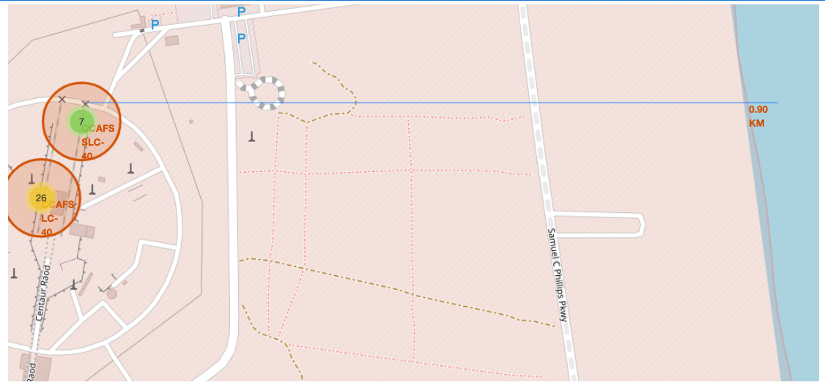
TODO: Similarly, you can draw a line betwee a launch site to its closest city, railway, highway, etc. You need to use MousePosition to find the their coordinates on the map first
A railway map symbol may look like this:
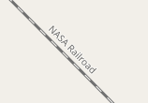
A highway map symbol may look like this:
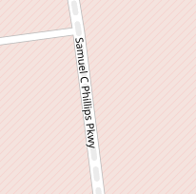
A city map symbol may look like this:
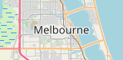
TODO: Similarly, you can draw a line betwee a launch site to its closest city, railway, highway, etc. You need to use MousePosition to find the their coordinates on the map first
# Create a marker with distance to a closest city, railway, highway, etc.
# Draw a line between the marker to the launch site
# Create a marker with distance to a closest city, railway, highway, etc.
# City (Orlando)
feature_lat = 28.538336
feature_lon = -81.379234

# CCAFS LC40 Coordinates
launch_lat = 28.562302
launch_lon = -80.577356
# determine the distance
distance = calculate_distance(launch_lat, launch_lon, feature_lat, feature_lon)
# Add a marker feature
folium.Marker(
location=[feature_lat, feature_lon],
popup="Closest City",
icon=folium.Icon(color='blue')
).add_to(site_map)

# Add a folium Marker
folium.Marker(
location=[feature_lat, feature_lon],
icon=DivIcon(
icon_size=(150, 36),
icon_anchor=(0, 0),
html='<div style="font-size: 12px; color:#d35400;"><b>%s</b></div>' % "{:10.2f} KM".format(distance),
)
).add_to(site_map)
Result: <folium.map.Marker at 0x66f29e0>
# Draw a line between the marker to the launch site
lines = folium.PolyLine(
locations=[[launch_lat, launch_lon], [feature_lat, feature_lon]],
weight=1,
color='blue'
)
site_map.add_child(lines)

After you plot distance lines to the proximities, you can answer the following questions easily:
- Are launch sites in close proximity to railways?
- Are launch sites in close proximity to highways?
- Are launch sites in close proximity to coastline?
- Do launch sites keep certain distance away from cities?
Also please try to explain your findings.
# A city near Cape Canaveral is Orlando at 78.39 KM which is right on the Coastline.
# I would imagine they want to stay a distance away as to avoid rockets coming down accidentally in a city.
# I-95 is a major highway and that is closer than Orlando but considering rockets try to go out over way they want to avoid being more people.
# There is a railway going past Cape Canaveral but that is a little West of it - closer to I-95 but still not on the coast near Cape Canaveral.

